**You Wu**

Date of Experiment: 10/21/2014

Date of Report: 10/26/2014

**ECE 221 Lab #3: MOSFET Characteristics and Biasing**

**Part I**

The drain current was measured across varying gate-source and drain-source voltages in the circuit shown in figure 1. The data is shown in the table below.

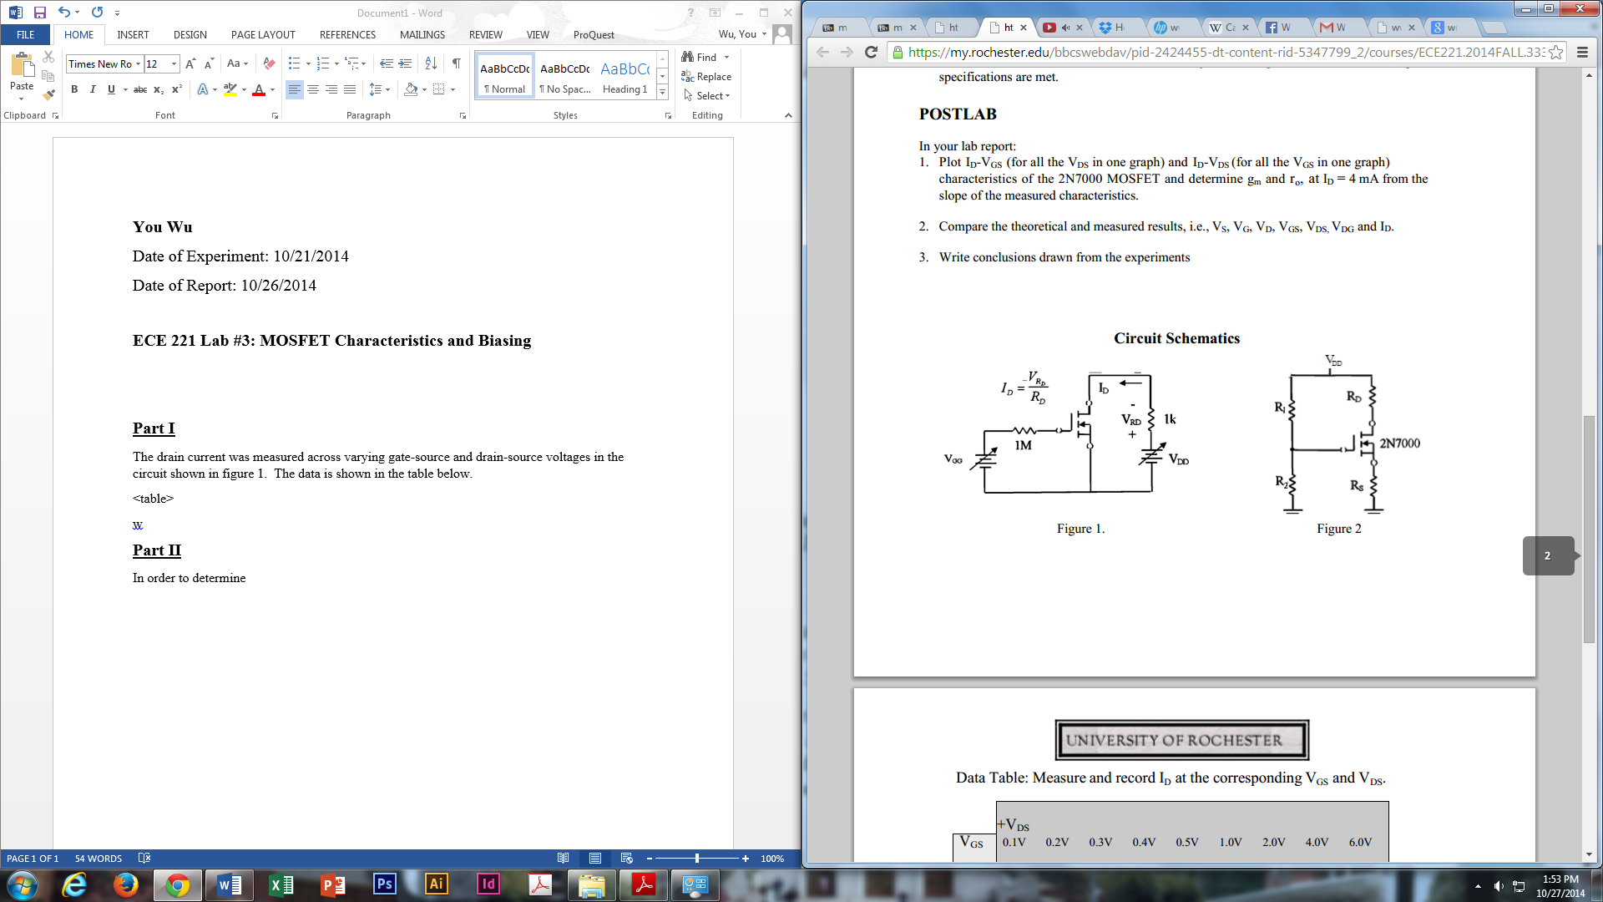

Table of ID (mA)

|  |  |  |  |  |  |  |  |  |  |
| --- | --- | --- | --- | --- | --- | --- | --- | --- | --- |
|  | VDS (V) |  |  |  |  |  |  |  |  |
| VGS (V) | 0.1 | 0.2 | 0.3 | 0.4 | 0.5 | 1.0 | 2.0 | 4.0 | 6.0 |
| 2.25 | 64 | 105 | 118 | 121 | 122 | 126 | 129 | 132 | 136 |
| 2.0 | 5 | 5 | 5 | 5 | 5 | 6 | 6 | 6 | 6 |
| 1.5 | 0 | 0 | 0 | 0 | 0 | 0 | 0 | 0 | 0 |
| 1.0 | 0 | 0 | 0 | 0 | 0 | 0 | 0 | 0 | 0 |
| 0.8 | 0 | 0 | 0 | 0 | 0 | 0 | 0 | 0 | 0 |

From the first graph, it is observed that the threshold voltage is approximately VGS = 1.53V.

The best estimate that was attempted for r0 at ID = 4mA was $\frac{1}{0.1917}=5.216mΩ$.

**Part II**

The circuit in figure 2 was built and the following characteristics were measured.

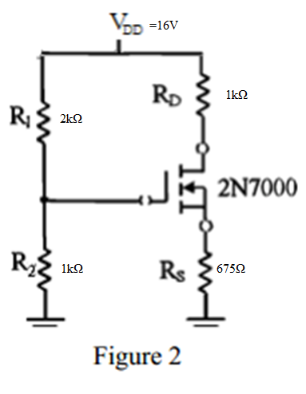

Data Collected Theoretical

|  |  |  |  |  |  |  |  |
| --- | --- | --- | --- | --- | --- | --- | --- |
| Vs | .031V | VGS | 2.01V | Vs | .031V | VGS | 2.01V |
| VG | 2.05V | VDS | 14.55V | VG | 5.33V | VDS | 14.55V |
| VD | .03V | VDG | 13.87V | VD | .03V | VDG | 13.87V |
| ID | .06A |  |  | ID | .06A |  |  |
|  |  |  |  | R0 |  |  |  |
|  |  |  |  | VTH | 1.53V | VOV |  |

It is very likely that the circuit did not function as expected. This is made evident by the glaringly unexpected VG measurement of 2.05V given the resistor values R1 and R2. In fact, during the lab, the value of VG was particularly fiddled with such that VG should be approximately 2.0V. Eventually, resistor values for R1 and R2 were found such that the condition was satisfied.